Packet Tracer 6 - DHCP and DNS Servers

1. Topology

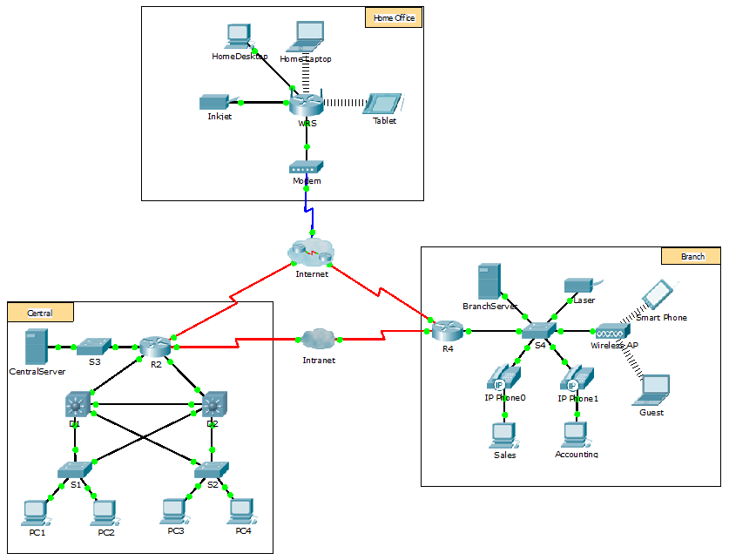

Objectives

Part 1: Configure Static IPv4 Addressing

Part 2: Configure and Verify DNS Records

1. Background

In this activity, you will configure and verify static IP addressing and DHCP addressing. You will then configure a DNS server to map IP addresses to the website names.

**Note**: Packet Tracer only simulates the process for configuring these services. DHCP and DNS software packages each have their own unique installation and configuration instructions.

1. Configure Static IPv4 Addressing
   1. Configure the Inkjet printer with static IPv4 addressing.

The home office computers need to know the printer’s IPv4 address to send information to it. The printer, therefore, must use a static (unchanging) IPv4 address.

* + 1. Click **Inkjet** and click the **Config** tab, which displays the Global Settings.
    2. Statically assign the Gateway address as **192.168.0.1** and the DNS Server address as **64.100.8.8**.
    3. Click **FastEthernet0** and statically assign the IP address as **192.168.0.2** and the Subnet Mask address as **255.255.255.0**.
    4. Close the Inkjet window.
  1. Configure WRS to provide DHCP services.
     1. Click **WRS** and click the **GUI** tab, and maximize the window.
     2. The Basic Setup window displays, by default. Configure the following settings in the Network Setup section:
        1. Change the IP Address to **192.168.0.1**.
        2. Set the Subnet Mask to **255.255.255.0**.
        3. Enable the DHCP Server.
        4. Set the Static DNS 1 address to **64.100.8.8**.
        5. Scroll to the bottom and click **Save**.
     3. Close the **WRS** window.
  2. Request DHCP addressing for the home laptop.

This activity focuses on the home office. The clients that you will configure with DHCP are **Home Laptop** and **Tablet**.

* + 1. Click **Home Laptop** and click the **Desktop** tab > **IP Configuration**.
    2. Click **DHCP** and wait until the DHCP request is successful.
    3. **Home Laptop** should now have a full IP configuration. If not, return to Step 2 and verify your configurations on **WRS**.
    4. Close the IP Configuration window and then close the **Home Laptop** window.
  1. Request DHCP addressing for the tablet.
     1. Click **Tablet** and click the **Desktop** tab > **IP Configuration**.
     2. Click **DHCP** and wait until the DHCP request is successful.
     3. **Tablet** should now have a full IP configuration. If not, return to Step 2 and verify your configurations on **WRS**.
  2. Test access to websites.
     1. Close the **IP Configuration** window, and then click Web Browser.
     2. In the URL box, type **10.10.10.2** (for the **CentralServer** website) or **64.100.200.1** (for the **BranchServer** website) and click **Go**. Both websites should appear.
     3. Reopen the web browser. Test the names for those same websites by entering **centralserver.pt.pka** and **branchserver.pt.pka**. Click on **Fast Forward Time** on the yellow bar below the topology to speed the process.

1. Configure Records on the DNS Server
   1. Configure famous.dns.pka with records for CentralServer and BranchServer.

Typically, DNS records are registered with companies, but for the purposes of this activity you control the **famous.dns.pka** server on the Internet.

* + 1. Click the **Internet** cloud. A new network displays.
    2. Click **famous.dns.pka** and click the **Services** tab > **DNS**.
    3. Add the following resource records:

|  |  |
| --- | --- |
| Resource Record Name | Address |
| centralserver.pt.pka | 10.10.10.2 |
| branchserver.pt.pka | 64.100.200.1 |

* + 1. Close the famous.dns.pkawindow.
    2. Click **Back** to exit the **Internet** cloud.
  1. Verify the ability of client computers to use DNS.

Now that you have configured DNS records, **Home Laptop** and **Tablet** should be able to access the websites by using the names instead of the IP addresses. First, check that the DNS client is working properly and then verify access to the website.

* + 1. Click **Home Laptop** or **Tablet**.
    2. If the web browseris open, close it and select **Command Prompt**.

Verify the IPv4 addressing by entering the command **ipconfig /all**. You should see the IP address for the DNS server.

* + 1. Ping the DNS server at **64.100.8.8** to verify connectivity.

**Note**: The first two or three pings may fail as Packet Tracer simulates all the various processes that must occur for successful connectivity to a remote resource.

Test the functionality of the DNS server by entering the commands **nslookup centralserver.pt.pka** and **nslookup branchserver.pt.pka**. You should get a name resolution showing the IP address for each.

* + 1. Close the Command Prompt window and click **Web Browser**. Verify that **Home Laptop** or **Tablet** can now access the web pages for **CentralServer** and **BranchServer**.